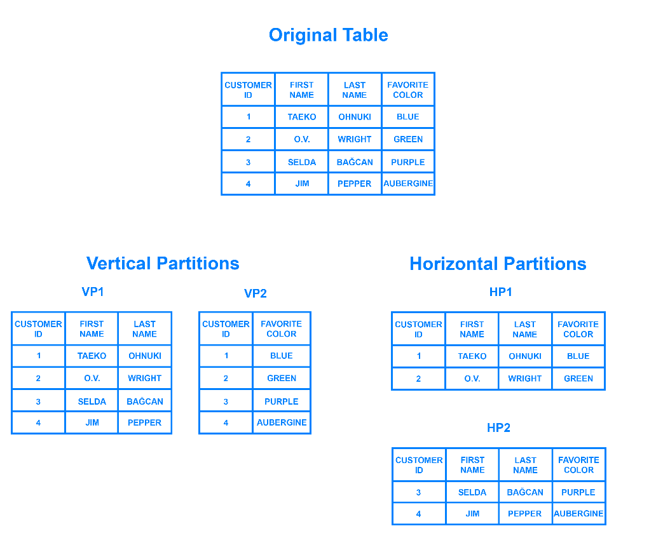

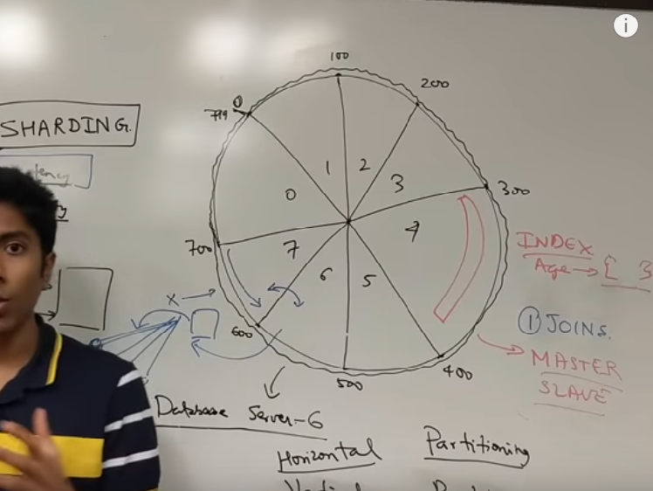

Database Partitioning:

- Divide the data between multiple tables in one database instances

Two types:

- Vertical

- Divide the data using columns

- Horizontal

- Divide the data using rows

- also known as sharding

A database can be split vertically — storing different tables & columns in a separate database,

or horizontally — storing rows of a same table in multiple database nodes.

Database sharding:

- Divide the data between multiple tables created in separate database instances.

- Sharding is a method of splitting and storing a single logical dataset in multiple databases.

- Sharding is necessary if a dataset is too large to be stored in a single database

- Sharding is also referred as horizontal partitioning.

- Sharding can be implemented at either the application or database level.

- assandra, HBase, HDFS, and MongoDB are popular distributed databases.

- Notable examples of non-sharded modern databases are Sqlite, Redis (spec in progress), Memcached, and Zookeeper.

- If your application is bound by read performance, you can add caches or database replicas.

- Shard or Partition Key is a portion of primary key which determines how data should be distributed.

- A partition key allows you to retrieve and modify data efficiently by routing operations to the correct database.

- Consistency and availability is important

Two types:

- Algorithmic sharding

- In algorithmic sharding, the client can determine a given partition’s database without any help.

- A simple sharding function may be “hash(key) % NUM_DB”.

- Dynamic Sharding

- In dynamic sharding, a separate locator service tracks the partitions amongst the nodes.

- The locator service becomes a single point of contention and failure.

Problems:

- Joins across shards

- dynamic no of shards => can be solved using hierarchical sharding

Index on sharding => Read/Write performance goes up

Shard fails => Master/Slave architecture can be useful

Alternatives to sharding:

- Indexing

- Use of NoSQL databases which internally uses sharding mechanism